**Custom Styled Component (Custom Building Blocks)**

**Description**

In this Document we have created some Custom-building block with the help of existing widgets and building block.

To reduce the dev efforts in future by creating custom building blocks. According to the Project requirement and use case Devs can modify it further.  
Provide a collection of commonly used icons, images, and widgets as part of the building blocks. This saves time by avoiding searching for or creating new building blocks for every UI element.

### **Typical usage scenario**

The Custom Styled Component module gives standard customization of building blocks. The module provides us with a collection of six building blocks -

1. Custom Styled DataGrid2.
2. Card PopUp Menu with Image.
3. Simple Footer.
4. Custom Footer.
5. Breadcrumb Badget.
6. Breadcrumb Ribbon.

### **Features and limitations**

1. The app provides a user-friendly and intuitive interface, making it easy for users to navigate and customize their custom-styled building blocks.

### **Dependencies**

1. Require Mendix 9.18.4 or above.

### **Installation**

1. Download the module from the marketplace.
2. Import it into your application.
3. When you will Install this component into your project, you may get some widget update error. For that you just need to right-click on that error and click on update all widgets.

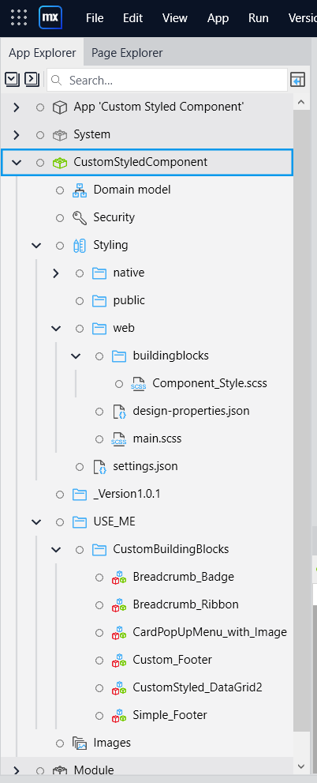

Custom Styling Building Blocks - Breadcrumbs

Custom Styling Building Blocks – Card with Action Popup  
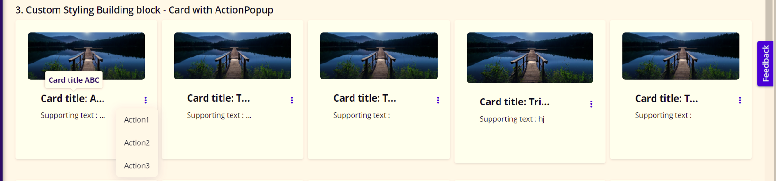

Custom Styling Building Blocks – Footer  
  


Custom Styling Building Blocks – DataGrid2  
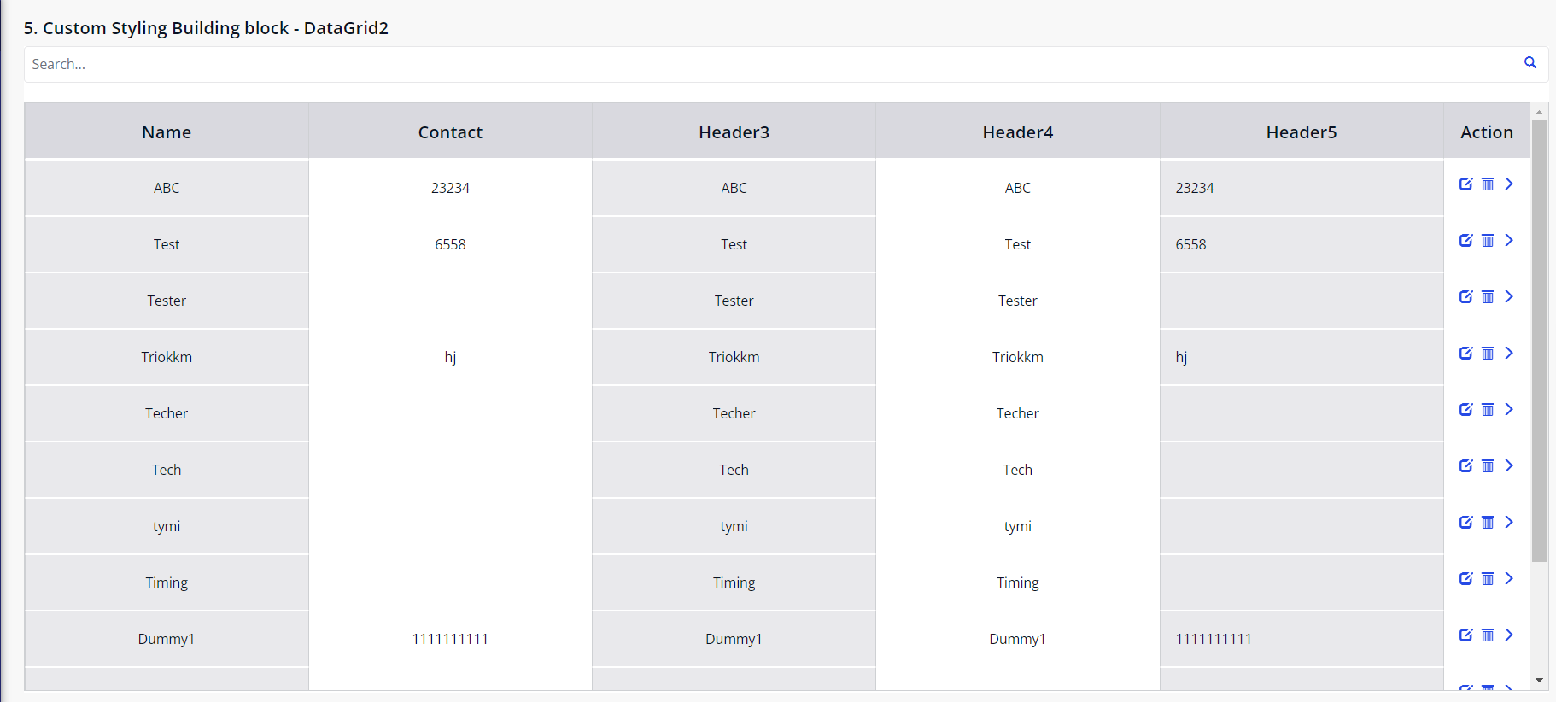  
**Configuration: NA**

**Category: Module**

**Subcategory: All**

**Visibility: Public Marketplace**

**Studio Pro Version: 9.18.4**